**DATABASE MANAGEMENT SYSTEMS LAB**

NAME-LEPAKSHI JAGMOHAN

SAPID-500119039

RNO-R2142230040

BATCH-2

**Experiment 16**

**To understand the concepts of Trigger.**

**1. Using implicit cursor update the salary by an increase of 10% for all the records in EMPLOYEES table, and finally display how many records have been updated. If no records exist display the message “No Change”. Creating STUDENT Table:**

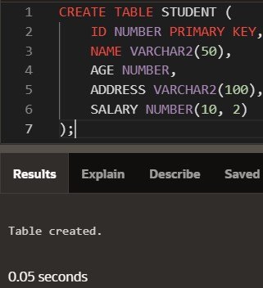

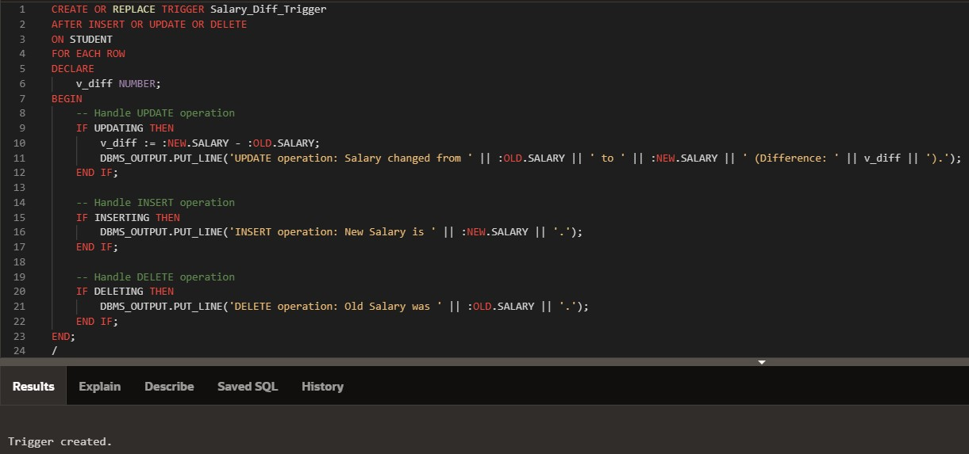**INPUT:**

**OUTPUT:**

**Inserting:**

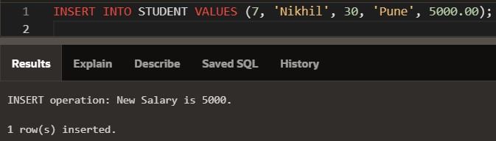

**Updating:**

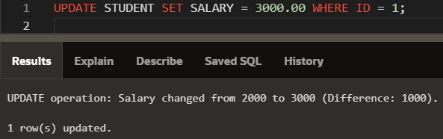

**Deleting:**

